 | Swisher Commercial Press Release
  David Hamilton, CCIM  Ronald Dankert  Douglas Smith  Barton Wise  John Evans | Tony Caprarese  Mike Jurgenson, CCIM  Charlie Koenn  Mike Giraud  Randy Maas | Gretchen Driskell  Jeff Evans  Joe Palms  Kyle Bamm  Joseph Merkel
  Tony Caprarese  Mike Jurgenson, CCIM  Charlie Koenn  Mike Giraud  Randy Maas | Tony Caprarese  Mike Jurgenson, CCIM  Charlie Koenn  Mike Giraud  Randy Maas | Gretchen Driskell  Jeff Evans  Joe Palms  Kyle Bamm  Joseph Merkel
  Jeff Evans  Joe Palms | Tony Caprarese  Mike Jurgenson, CCIM  Charlie Koenn  Mike Giraud  Randy Maas | Gretchen Driskell  Jeff Evans  Joe Palms  Kyle Bamm  Joseph Merkel

Date: 07/01/2020

To: Press Release Distribution List

From: Cyd Debol, Office Operations Manager

734-663-0501

cdebol@swishercommercial.com

Noelle Caprarese, Administrative Assistant

noellec@swishercommercial.com

www.swishercommercial.com

Subject: Swisher Commercial sold 1.06 acres of vacant land in Manchester
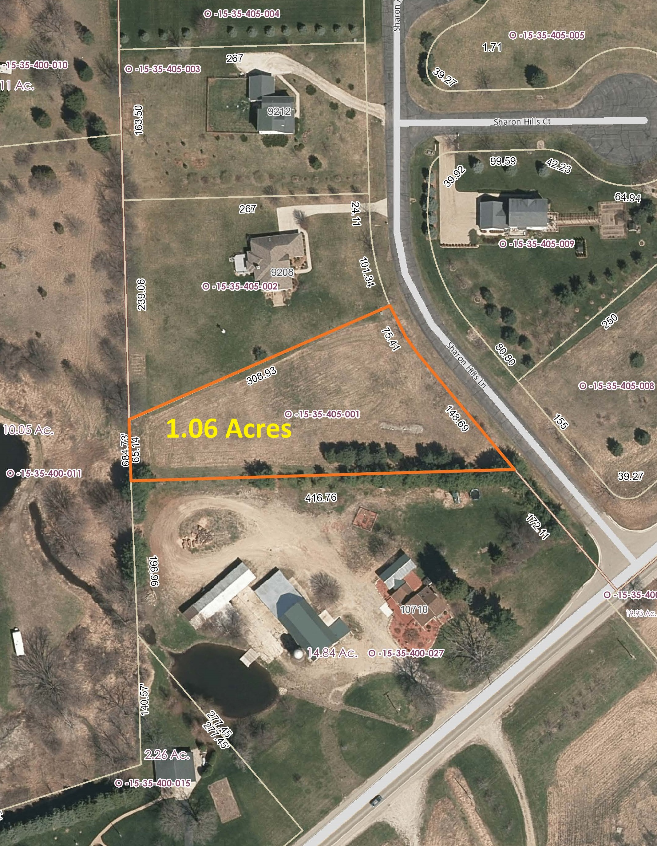
Swisher Commercial is pleased to announce the sale of 1.06 acres of vacant land at 1 Sharon Hills, Manchester.

Charlie Koenn of Swisher Commercial represented the listing. Charlie can be reached by phone at (734) 926-0230 and by email at ckoenn@swishercommercial.com.

Swisher Commercial is a full-service, independent brokerage firm specializing in commercial real estate and investment properties. Services include sales, leasing, property management and consulting, as well as sales of vacant land. Swisher Commercial’s longevity in the industry and commitment to the community supports its strong reputation for integrity, experience and results. It continues to be one of the largest commercial brokerage firms headquartered in Ann Arbor and serving Washtenaw, Lenawee and Jackson counties.

