Natalie Flora of Interior Environments has a Bachelors Degree of Science in Interior Design. She has worked with Interior Environments studying workplace strategy for 15 years. She has worked with many top performing companies to create major cultural changes within their organization. Most recently studying and sharing insights and knowledge relating to the return to work planning and re-imagination of the workplace post pandemic.

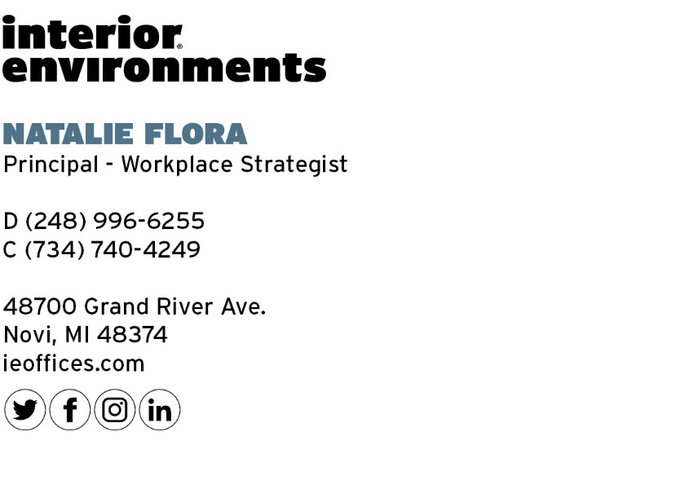
Additional contact: Nigel Addison
248.213.3010
naddison@ieoffices.com

