Commercial Board of REALTORS - 2020

Reimagination of the Workplace Post Pandemic

Instructor, Natalie Flora

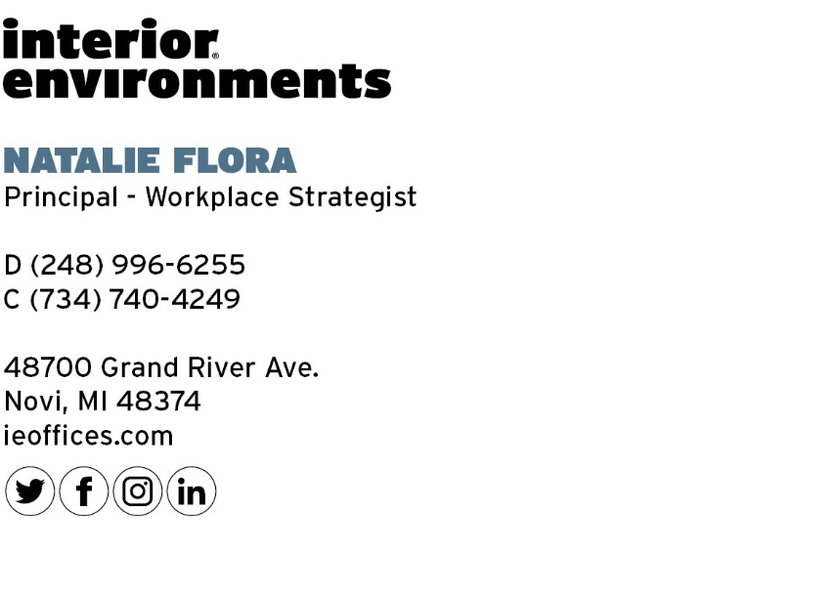
Session Outline
- Introduction - 5 min
Our goal is to take the most important topics, research, data and insights from real customers and put it in one place to give you content to think about. As you navigate these uncharted waters, we want to be a resource and hopefully give you something to think about that you haven’t heard before. We aim to confirm your decisions and leave you feeling confident about the choices you are making.
What were driving factors of workplace design before the pandemic and what are the new social norms affected the driving factors post pandemic. What will change.
- RTW Initiative, Post Pandemic Planning
Short Term + Long Term Strategies – 10 min

Risk Management – 5 min

Work from Home – 5 min

Change Management – 5 min
- Reimagination of the Workplace
Why are we going back to Work? - 5 min

Workplace of the Future - 10 min

Social Distancing in the Office - 5 min

