 | Swisher Commercial Press Release
  David Hamilton, CCIM  Ronald Dankert  Douglas Smith  Barton Wise  John Evans | Tony Caprarese  Mike Jurgenson, CCIM  Charlie Koenn  Mike Giraud  Randy Maas | Gretchen Driskell  Jeff Evans  Joe Palms  Kyle Bamm  Joseph Merkel
  Tony Caprarese  Mike Jurgenson, CCIM  Charlie Koenn  Mike Giraud  Randy Maas | Tony Caprarese  Mike Jurgenson, CCIM  Charlie Koenn  Mike Giraud  Randy Maas | Gretchen Driskell  Jeff Evans  Joe Palms  Kyle Bamm  Joseph Merkel
  Jeff Evans  Joe Palms  Kyle Jurgenson | Tony Caprarese  Mike Jurgenson, CCIM  Charlie Koenn  Mike Giraud  Randy Maas | Gretchen Driskell  Jeff Evans  Joe Palms  Kyle Bamm  Joseph Merkel

Date: 11/19/2020

To: Press Release Distribution List

From: Cyd Debol, Office Operations Manager

734-663-0501

cdebol@swishercommercial.com

Jessie Wise, Senior Marketing Coordinator

jwise@swishercommercial.com

www.swishercommercial.com

Subject: Swisher Commercial leased 5,040 SF industrial suite in Manchester

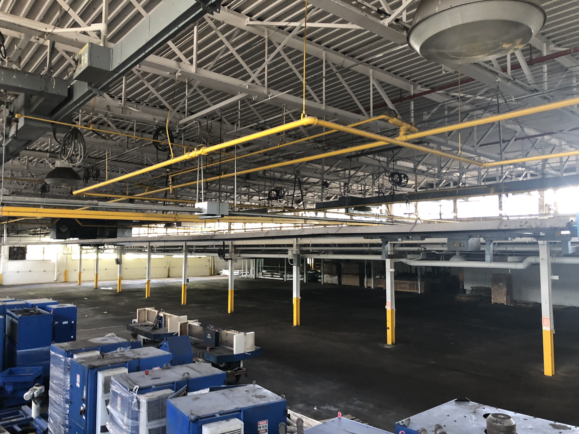

Swisher Commercial is pleased to announce the lease of 5,040 SF industrial space at 715 Duncan, Suite X, Manchester.

Jeff Evans and Charlie Koenn of Swisher Commercial were the listing agents for this property. Jeff can be reached by phone at (734) 926-0222 and by e-mail at jeffevans@swishercommercial.com. Charlie can be reached by phone at (734) 926-0230 and by e-mail at ckoenn@swishercommercial.com.

Swisher Commercial is a full-service, independent brokerage firm specializing in commercial real estate and investment properties. Services include sales, leasing, property management and consulting, as well as sales of vacant land. Swisher Commercial’s longevity in the industry and commitment to the community supports its strong reputation for integrity, experience and results. It continues to be one of the largest commercial brokerage firms headquartered in Ann Arbor and serving Washtenaw, Lenawee and Jackson counties.

