 | Swisher Commercial Press Release
  David Hamilton, CCIM  Ronald Dankert  Douglas Smith  Barton Wise  John Evans | Tony Caprarese  Mike Jurgenson, CCIM  Charlie Koenn  Mike Giraud  Randy Maas | Gretchen Driskell  Jeff Evans  Joe Palms  Kyle Bamm  Joseph Merkel
  Tony Caprarese  Mike Jurgenson, CCIM  Charlie Koenn  Mike Giraud  Randy Maas | Tony Caprarese  Mike Jurgenson, CCIM  Charlie Koenn  Mike Giraud  Randy Maas | Gretchen Driskell  Jeff Evans  Joe Palms  Kyle Bamm  Joseph Merkel
  Jeff Evans  Joe Palms  Kyle Jurgenson | Tony Caprarese  Mike Jurgenson, CCIM  Charlie Koenn  Mike Giraud  Randy Maas | Gretchen Driskell  Jeff Evans  Joe Palms  Kyle Bamm  Joseph Merkel

Date: 12/22/2020

To: Press Release Distribution List

From: Cyd Debol, Office Operations Manager

734-663-0501

cdebol@swishercommercial.com

Jessie Wise, Senior Marketing Coordinator

jwise@swishercommercial.com

www.swishercommercial.com

Subject: Swisher Commercial leased 2,220 SF office space in Ypsilanti

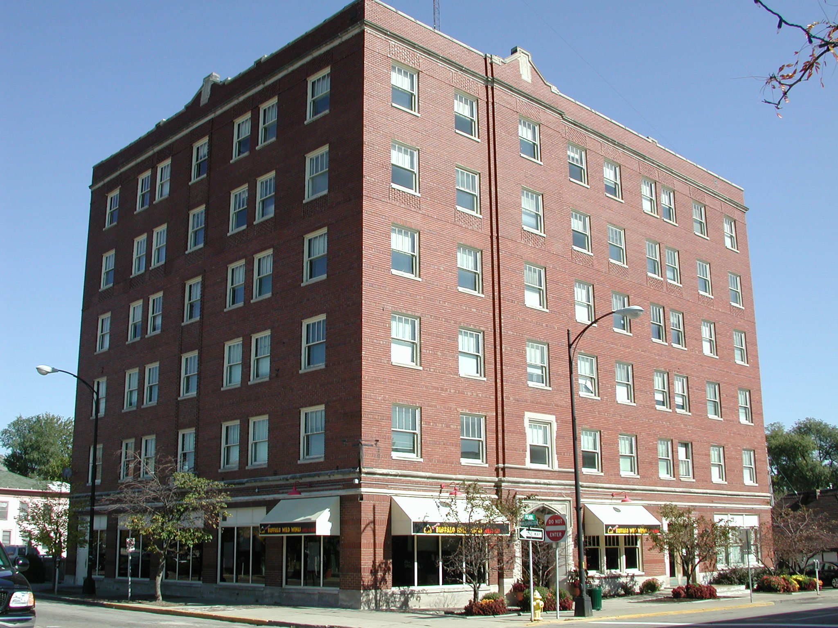

Swisher Commercial is pleased to announce the lease of 2,220 SF office space at Centennial Plaza, 124 Pearl, Suites 205 / 206 / 207, Ypsilanti.

Tony Caprarese of Swisher Commercial was the listing and leasing agent for this property. Tony can be reached by phone at (734) 22-7520 and by e-mail at tonyc@swishercommercial.com.

Swisher Commercial is a full-service, independent brokerage firm specializing in commercial real estate and investment properties. Services include sales, leasing, property management and consulting, as well as sales of vacant land. Swisher Commercial’s longevity in the industry and commitment to the community supports its strong reputation for integrity, experience and results. It continues to be one of the largest commercial brokerage firms headquartered in Ann Arbor and serving Washtenaw, Lenawee and Jackson counties.

