 | Swisher Commercial Press Release
  David Hamilton, CCIM  Ronald K. Dankert  Douglas Smith, CCIM  Barton Wise | Tony Caprarese  Mike Jurgenson, CCIM  Charlie Koenn  Mike Giraud  Randy Maas | Gretchen Driskell  Jeff Evans  Joe Palms  Kyle Bamm  Joseph Merkel
  Tony Caprarese  Michael Jurgenson, CCIM  Charlie Koenn  Mike Giraud | Tony Caprarese  Mike Jurgenson, CCIM  Charlie Koenn  Mike Giraud  Randy Maas | Gretchen Driskell  Jeff Evans  Joe Palms  Kyle Bamm  Joseph Merkel
  Jeff Evans  Joseph Palms, CCIM  Randy Maas | Tony Caprarese  Mike Jurgenson, CCIM  Charlie Koenn  Mike Giraud  Randy Maas | Gretchen Driskell  Jeff Evans  Joe Palms  Kyle Bamm  Joseph Merkel

Date: 01/19/2021

To: Press Release Distribution List

From: Cyd Debol, Office Operations Manager

734-663-0501

cdebol@swishercommercial.com

Jessie Wise, Senior Marketing Coordinator

jwise@swishercommercial.com

www.swishercommercial.com

Subject: Swisher Commercial leased 200 SF office space in Ann Arbor

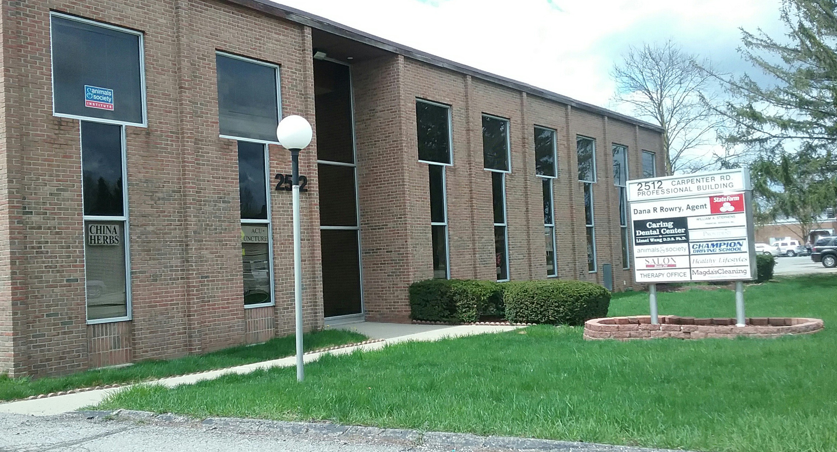

Swisher Commercial is pleased to announce the lease of 200 SF office space at 2512 Carpenter, Ann Arbor.

Bart Wise of Swisher Commercial was the listing agent for this property. Bart can be reached by phone at (734) 662-3778 and by e-mail at bartw@swishercommercial.com. Joe Palms of Swisher Commercial was the listing and leasing agent for this deal. Joe can be reached by phone at (734) 662-3676 and by e-mail at jpalms@swishercommercial.com.

Swisher Commercial is a full-service, independent brokerage firm specializing in commercial real estate and investment properties. Services include sales, leasing, property management and consulting, as well as sales of vacant land. Swisher Commercial’s longevity in the industry and commitment to the community supports its strong reputation for integrity, experience and results. It continues to be one of the largest commercial brokerage firms headquartered in Ann Arbor and serving Washtenaw, Lenawee and Jackson counties.

